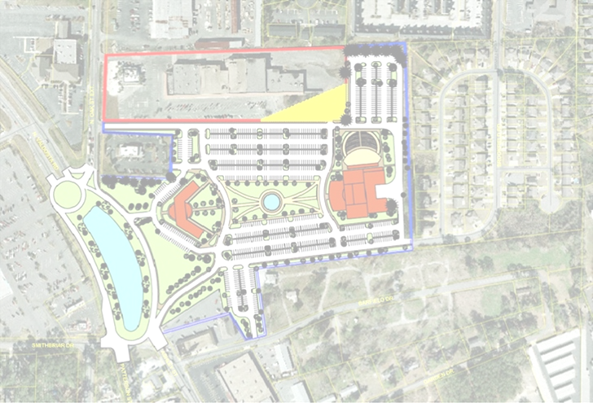

LOWNDES COUNTY LIBRARY

BUILDING PROGRAM
FOR THE SOUTH GEORGIA
REGIONAL LIBRARY SYSTEM

APRIL 30, 2012

Prepared by:
Kathryn Ames
Greg Heid

